Jenkins Assignment 7 using pipeline
Create 1 project LoginWebApp ,build and run then take backup on github and install 2nd instance then open Jenkins in that 2nd instance and add this project
Step 1 – install 1st instance then set up java,maven ,tomcat,Jenkins create project and check
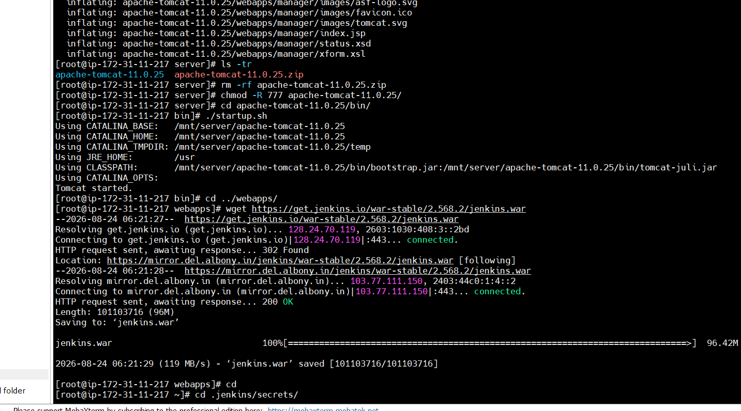
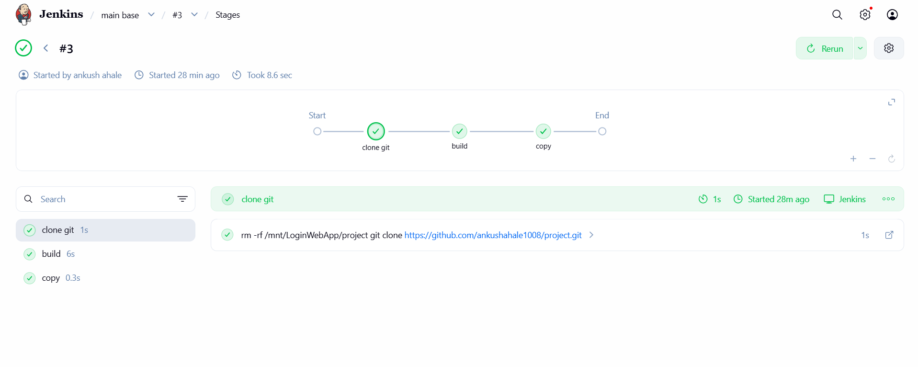
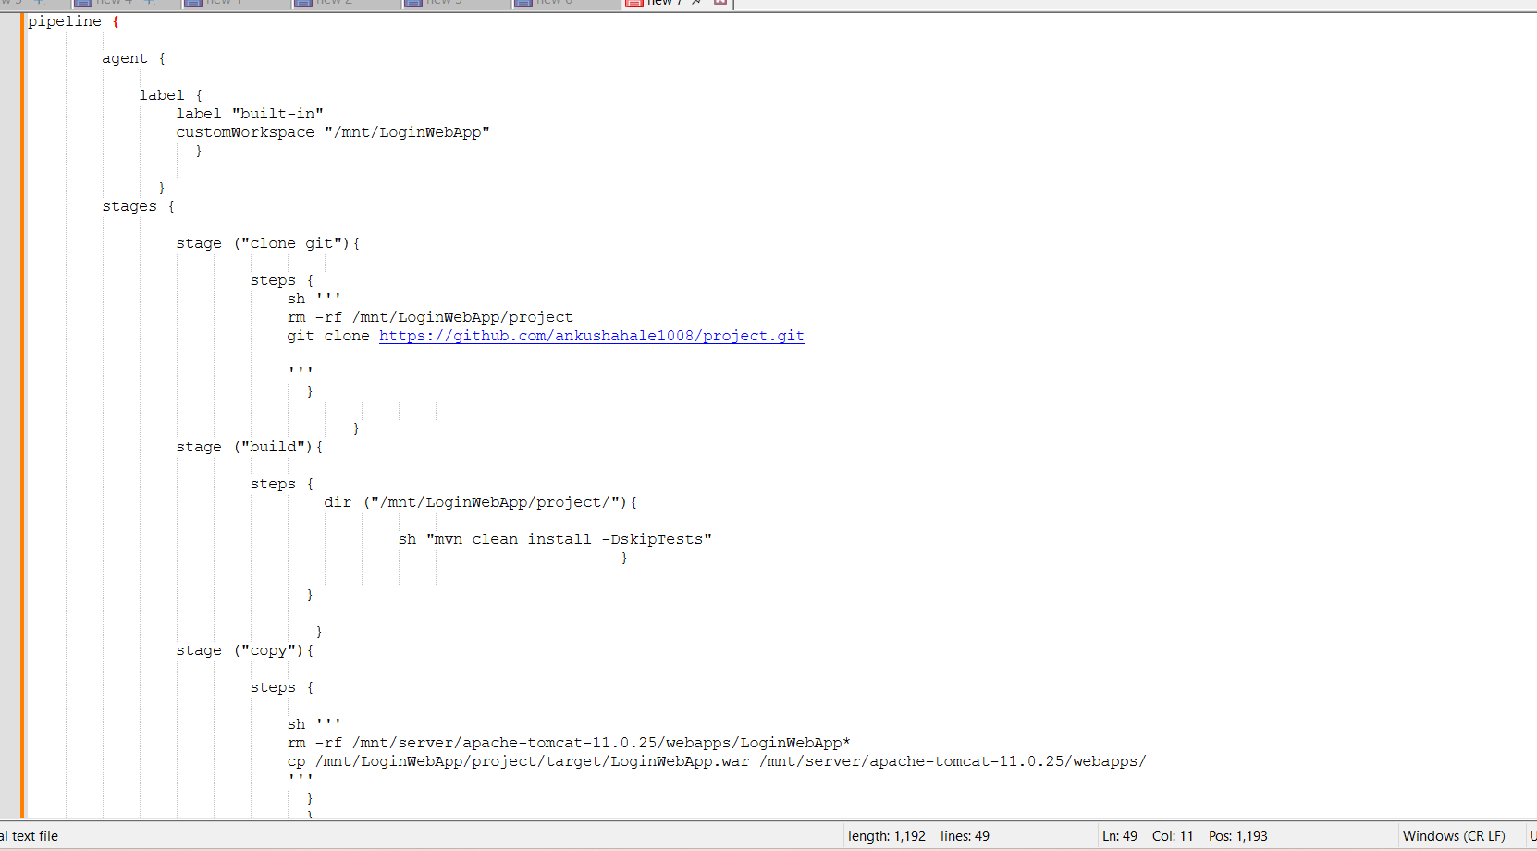
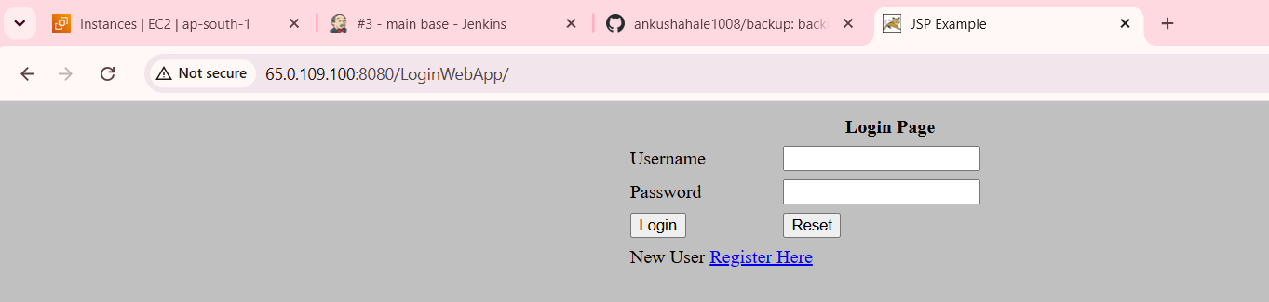
Step 2 – create 1 github repo and add this project to that repo
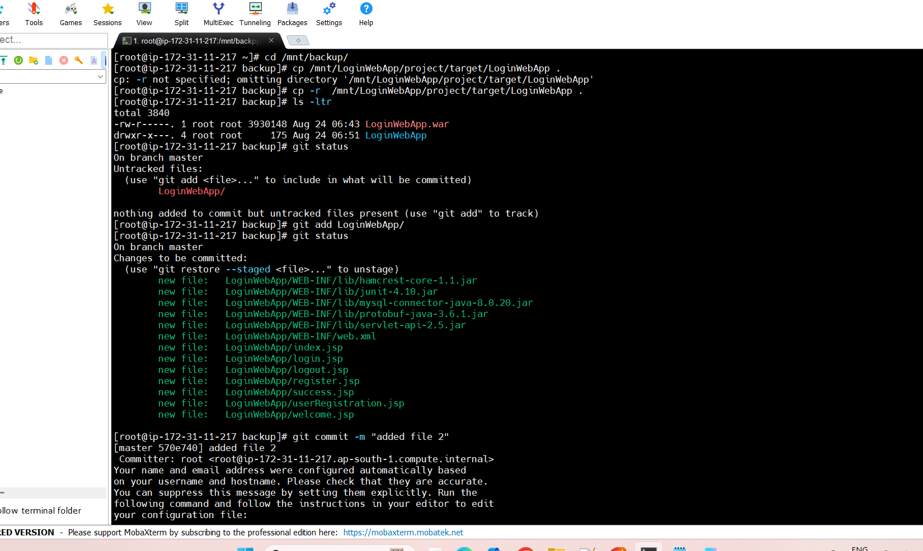
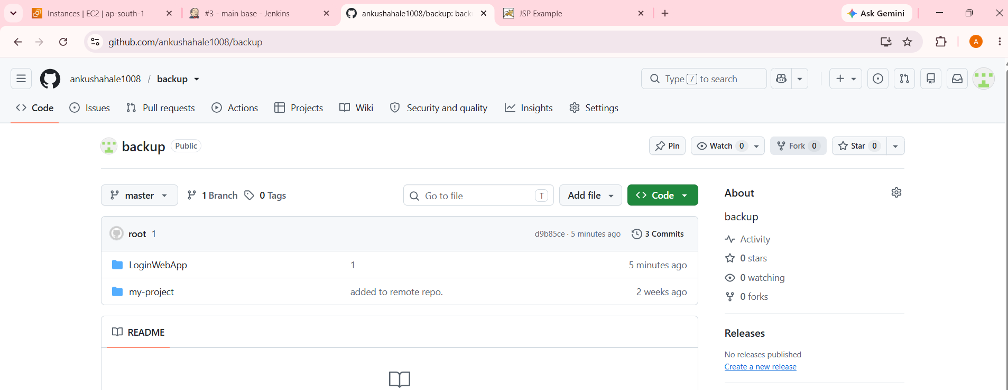
Step 3 – now install 2nd instance setup maven tomcat Jenkins and clone project then add this project in to .jenkins/jobs
